Chapter 18, Problem 25.

Obtain the inverse Fourier transform of the following signals.
(a) 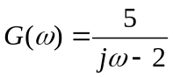
(b) 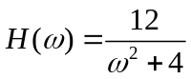
(c ) 